2018~2019第一学期《数据结构》上机实验报告（2017级理科实验班）
序号 | 班级 | 姓名 | 学号 | 完成模块
1 | 理试1701 | 朱帅成 | 41721603 | 类定义 主函数 窗体设计
2 | 理试1701 | 孙嘉彬 | 41721609 | 类定义 主函数 窗体设计
3 | 理试1701 | 芦明铭 | 41721610 | 类定义 主函数 窗体设计
4
指导教师：张志刚 |  |  |  | 助教：张林桐
实验名称： 树的结构与运算
实验任务：
根据字符串创建树
实现树的先根、后根、层序遍历
实现树的增删操作
实验目的：
学习并掌握树结构的创建与操作
学习并掌握树的遍历
了解C#中的树形控件
运行结果：
树的生成
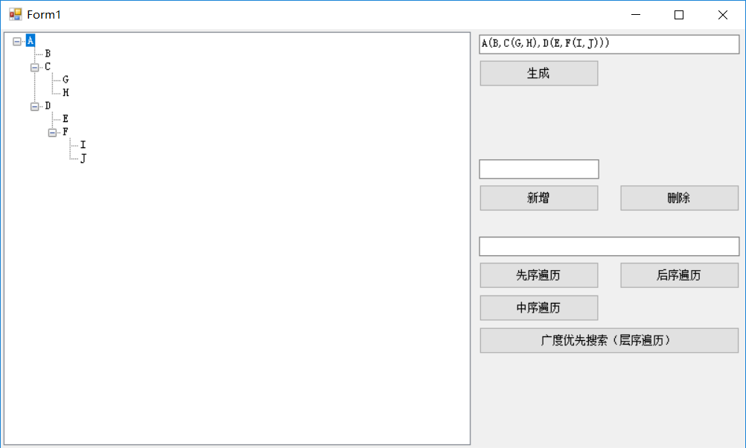

增加R、删除E
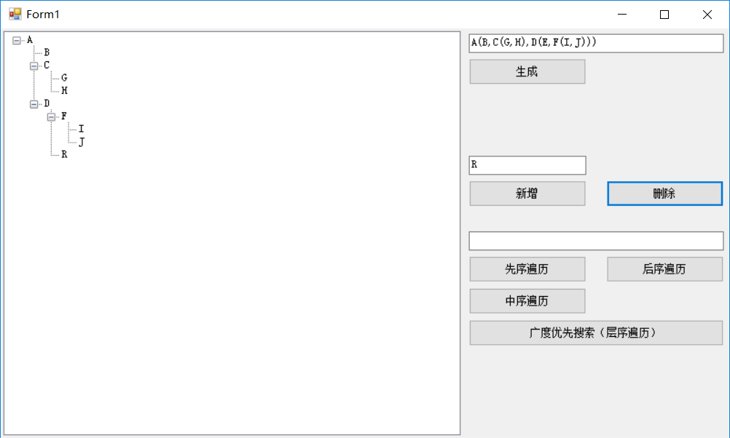

先序、后序、层序遍历
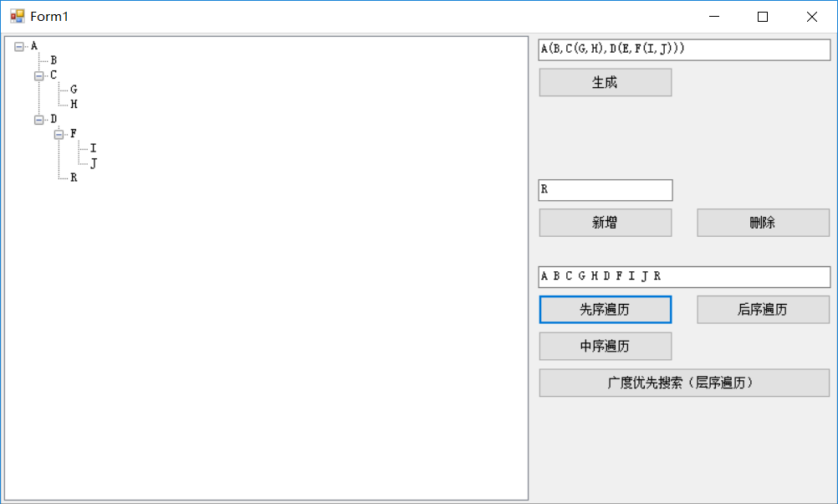
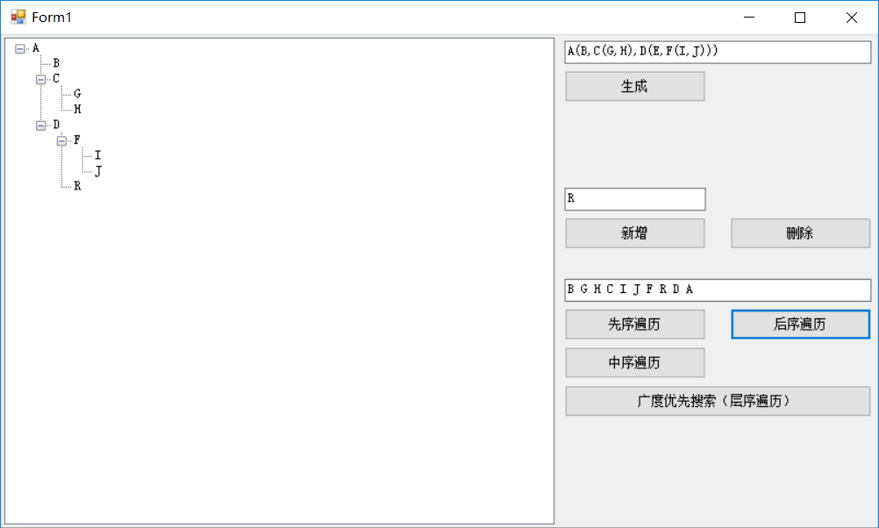
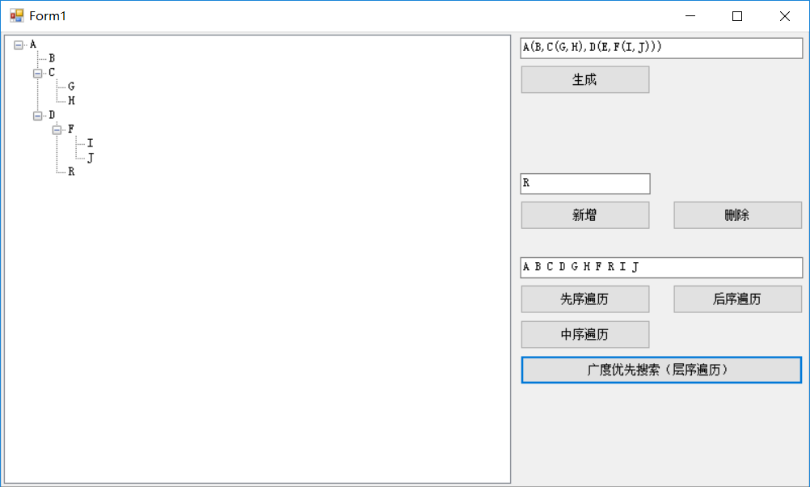
分析讨论：
树的结构比二叉树更加复杂，因而其储存多用多重链表表示，遍历等运算也更加复杂。但是仍然可以依靠栈和队列或者递归的方式实现。此外，根据树与其转化的二叉树的关系，可以推知树的先序遍历等价于相应二叉树的先序遍历，后序遍历等价于相应二叉树的中序遍历，层序遍历相当于相应二叉树的后序遍历，因此也可利用二叉树实现遍历。
心得体会：
经过此次实验，我们学习到了树的基本操作与遍历方法，基本掌握了树与二叉树的转化，并且能够利用栈和队列等方法对树进行遍历。树是十分常见的非线性结构，掌握树的相关运算也能极大地帮助我们今后的学习。

2018年 11月 6日
设计方案描述（类设计）：
using System;
using System.Collections.Generic;
using System.Text;
using System.Linq;
using System.Drawing;
using System.Windows.Forms;
using System.Threading;

namespace WTFTree
{
public interface ICStack<Type>//接口
{
bool IsEmpty();//判栈空
bool IsFull();//判栈满
void MakeEmpty();//清空
bool Push(Type item);//入栈
Type Pop();//出栈
Type Gettop();//取栈顶
string GetStackALLDate(string sname);
}

class CStacknode<Type>//链栈结点类
{
private Type data;
private CStacknode<Type> next;
//--------------------------------------------------------------------------------
public CStacknode()
{
next = null;
}
public CStacknode(Type data)
{
this.data = data;
next = null;
}
public CStacknode(Type data, CStacknode<Type> next)
{
this.data = data;
this.next = next;
}
public Type Data
{
get { return data; }
set { data = value; }
}
public CStacknode<Type> Next
{
get { return next; }
set { next = value; }
}
}
class CLinkStack<Type> : ICStack<Type>
{
private CStacknode<Type> top;
//--------------------------------------------------------------------------------
public void MakeEmpty() { top = null; }//清空
public bool IsEmpty() { return top == null; }//判栈空
public bool IsFull() { return false; }//判栈满

public CLinkStack()
{
top = null;
}
public bool Push(Type item)//入栈
{
top = new CStacknode<Type>(item, top);
return (true);
}
public Type Pop()//出栈
{
Type dt = top.Data;
top = top.Next;
return dt;
}
public Type Gettop()//取栈顶
{
if (top == null)
return default(Type);
else
return top.Data;
}
public string GetStackALLDate(string sname)
{
string str = " 】";
if (IsEmpty()) str = sname + " stack is null";
CStacknode<Type> p = top;
while (p != null)
{
str = p.Data + " " + str;
p = p.Next;
}
str = "【 " + str + "\r\n";
str = str + "---------------------------------------" + "\r\n";
return str;
}
}

public class CSeqStack<Type> : ICStack<Type>
{
private int top;
private Type[] elems;
private int Maxsize = 100;
//--------------------------------------------------------------------------------
public void MakeEmpty() { top = -1; }//清空
public bool IsEmpty() { return top == -1; }//判栈空
public bool IsFull() { return top == Maxsize - 1; }//判栈满
///////////////////////////////////////////////////////////
public Type this[int index]
{
get { return elems[index]; }
set { elems[index] = value; }
}
public int Top
{
get { return top; }
}

public CSeqStack()
{
elems = new Type[Maxsize];
top = -1;
}
public CSeqStack(int max)
{
Maxsize = max;
elems = new Type[Maxsize];
top = -1;
}
///////////////////////////////////////////////////////////
public bool Push(Type item)//入栈
{
if (!IsFull())
{
elems[++top] = item;
return (true);
}
else
return (false);
}
///////////////////////////////////////////////////////////
public Type Pop()//出栈
{
if (!IsEmpty())
return elems[top--];
else
return elems[0];
}
///////////////////////////////////////////////////////////
public Type Gettop()//取栈顶
{
if (!IsEmpty())
return elems[top];
else
return elems[0];
}
public string GetStackALLDate(string sname)
{
string str = "";
if (IsEmpty()) str = sname + " stack is null";
for (int i = 0; i <= top; i++)
{
str = str + " " + elems[i].ToString() + " ";
}
str = str + "\r\n";
//str = str + "--------------------------------------------------" + "\r\n";
return str;
}
///////////////////////////////////////////////////////////
}
public class CQueue<Type>
{
private int front, rear;
private Type[] elems;
private const int Maxsize = 1000;
//--------------------------------------------------------------------------------
public void MakeEmpty() { front = rear = 0; }//清空
public bool IsEmpty() { return front == rear; }//判队空
public bool IsFull() { return (rear + 1) % Maxsize == front; }//判队满
public int Front() { return front; }
public int Rear() { return rear; }
///////////////////////////////////////////////////////////
public CQueue()
{
elems = new Type[Maxsize];
front = rear = 0;
}
///////////////////////////////////////////////////////////
public bool In(Type item)//入队
{
if (!IsFull())
{
rear = (rear + 1) % Maxsize;
elems[rear] = item;
return (true);
}
else
return (false);
}
///////////////////////////////////////////////////////////
public Type Out()//出队
{
front = (front + 1) % Maxsize;
return elems[front];
}
///////////////////////////////////////////////////////////
public Type Getfront()
{
return elems[(front + 1) % Maxsize];
}
///////////////////////////////////////////////////////////
public Type Getdata(int k)
{
return elems[k];
}
///////////////////////////////////////////////////////////
}
public class drawbtreetype<Type>
{
public CBinaryTreenode<Type> pbtnode;
public double px, py;
public int level;
}; //画二叉树图时的辅助表
public class help<Type>
{
public int t1b, t2b, tln;//先序中开始位置,中序中开始位置,树长
public CBinaryTreenode<Type> adr;
}; //由先序序列,中序序列生成二叉树的帮助表
public class CBinaryTreenode<Type>
{
public Type data;
public bool isStepped = false;
public CBinaryTreenode<Type> lchild, rchild;
public CBinaryTreenode()
{
lchild = rchild = null;
}
public CBinaryTreenode(Type item)
{
data = item;
lchild = rchild = null;
}
public CBinaryTreenode(Type item, CBinaryTreenode<Type> lc, CBinaryTreenode<Type> rc)
{
data = item;
lchild = lc; rchild = rc;
}

}
class CBinaryTree
{
public CBinaryTreenode<int> treeroot;

public void CreateTreeview_str(string treestr, TreeView treeView1)
{
CLinkStack<TreeNode> stnode = new CLinkStack<TreeNode>();//存放树节点的栈
treeView1.Nodes.Clear();//清除原有树的结点
TreeNode stp = null;
TreeNode stpnew = null;

string strt = "1234567890+-*/";
char ch = ' ';
int n = treestr.Length;
for (int i = 0; i < n; i++)
{
ch = treestr[i];
if (((ch >= 'A') && (ch <= 'Z')) || ((ch >= 'a') && (ch <= 'z')) || (strt.IndexOf(ch) >= 0))
{
//取栈顶
stp = stnode.Gettop();
//创建节点并于栈顶链接
stpnew = new TreeNode();//创建新的树的结点
stpnew.Text = "" + ch;
if (stp == null)
treeView1.Nodes.Add(stpnew);//加为树的根节点
else
stp.Nodes.Add(stpnew);//加为树的根节点
}
else if (ch == '(')
stnode.Push(stpnew);//当前点入栈
else if (ch == ')')
stnode.Pop();//出栈
}

//tb_treeno.Text = Convert.ToString(treeView1.GetNodeCount(true));
treeView1.SelectedNode = treeView1.Nodes[0];
treeView1.SelectedNode.ExpandAll();
treeView1.Select();
}

public void DrawBTree(PictureBox pb_bstree)
{
CLinkStack<drawbtreetype<int>> stree = new CLinkStack<drawbtreetype<int>>();
drawbtreetype<int> sp, spt;
CBinaryTreenode<int> pbtnode, pbtnodenow;
if (treeroot == null)
return;
Graphics myg;
int xmin = 0;
int ymin = 0;
int xmax, ymax;

myg = pb_bstree.CreateGraphics();
xmax = pb_bstree.Width;
ymax = pb_bstree.Height;
//设置显示颜色
Color bkColor0;
Brush bkBrush0;
Brush bkbrush = new SolidBrush(Color.White);//背景色
bkColor0 = Color.FromArgb(255, 0, 255, 255);
bkBrush0 = new SolidBrush(bkColor0);
Pen pen1 = new Pen(Color.Red, 2);
//画背景
myg.FillRectangle(bkbrush, xmin, ymin, xmax - xmin, ymax - ymin);
string str;
Font font = new Font("Arial", 10);
SolidBrush b1 = new SolidBrush(Color.Blue);
StringFormat sf1 = new StringFormat();

//画图数据初始化
double xx = xmax / 2;
double yy = ymax - 50;
int level = 1;
double xnow;
double ynow;
double alpha;

double len = 150;
double lenbl = 0.8;
double dw = 0;
//画树根中心点
spt = new drawbtreetype<int>();
spt.pbtnode = treeroot;
spt.px = xx;
spt.py = yy;
spt.level = level;
stree.Push(spt);//树根入栈
myg.FillEllipse(bkBrush0, (int)(xx - 12), (int)(ymax - yy - 12), 24, 24);

myg.DrawEllipse(pen1, (int)(xx - 12), (int)(ymax - yy - 12), 24, 24);
str = "" + treeroot.data;
myg.DrawString(str, font, b1, (int)(xx - 5), (int)(ymax - yy - 8), sf1);
while (!stree.IsEmpty())
{
sp = stree.Pop();
pbtnode = sp.pbtnode;
xx = sp.px;
yy = sp.py;
level = sp.level;
//设置比例
if (level == 0)
{ lenbl = 0; dw = 0; }
else if (level == 1)
{ lenbl = 1; dw = 70; }
else if (level == 2)
{ lenbl = 0.8; dw = 40; }
else if (level == 3)
{ lenbl = 0.6; dw = 30; }
else if (level == 4)
{ lenbl = 0.5; dw = 20; }
else if (level == 5)
{ lenbl = 0.4; dw = 15; }
else
{ lenbl = 0.3; dw = 15; }
pbtnodenow = pbtnode.lchild;
if (pbtnodenow != null)
{
//设置转角
alpha = -90 - dw;
//求新点坐标
xnow = xx + len * lenbl * Math.Cos(alpha * 3.14 / 180.0);
ynow = yy + len * lenbl * Math.Sin(alpha * 3.14 / 180.0);
//画线
myg.DrawLine(pen1, (int)xx, (int)(ymax - yy), (int)xnow, (int)(ymax - ynow));
//画中心点
myg.FillEllipse(bkBrush0, (int)(xnow - 12), (int)(ymax - ynow - 12), 24, 24);

myg.DrawEllipse(pen1, (int)(xx - 12), (int)(ymax - yy - 12), 24, 24);
str = "" + pbtnode.data;
myg.DrawString(str, font, b1, (int)(xx - 5), (int)(ymax - yy - 8), sf1);

myg.FillEllipse(bkBrush0, (int)(xnow - 12), (int)(ymax - ynow - 12), 24, 24);

myg.DrawEllipse(pen1, (int)(xnow - 12), (int)(ymax - ynow - 12), 24, 24);
str = "" + pbtnodenow.data;
myg.DrawString(str, font, b1, (int)(xnow - 5), (int)(ymax - ynow - 8), sf1);

//左孩子结点入栈
spt = new drawbtreetype<int>();
spt.pbtnode = pbtnodenow;
spt.px = xnow;
spt.py = ynow;
spt.level = level + 1;
stree.Push(spt);
}
Thread.Sleep(100);
pbtnodenow = pbtnode.rchild;
if (pbtnodenow != null)
{
//设置转角
alpha = -90 + dw;
//求新点坐标
xnow = xx + len * lenbl * Math.Cos(alpha * 3.14 / 180.0);
ynow = yy + len * lenbl * Math.Sin(alpha * 3.14 / 180.0);
//画线
myg.DrawLine(pen1, (int)xx, (int)(ymax - yy), (int)xnow, (int)(ymax - ynow));
//画中心点
myg.FillEllipse(bkBrush0, (int)(xnow - 12), (int)(ymax - ynow - 12), 24, 24);

myg.DrawEllipse(pen1, (int)(xx - 12), (int)(ymax - yy - 12), 24, 24);
str = "" + pbtnode.data;
myg.DrawString(str, font, b1, (int)(xx - 5), (int)(ymax - yy - 8), sf1);

myg.FillEllipse(bkBrush0, (int)(xnow - 12), (int)(ymax - ynow - 12), 24, 24);

myg.DrawEllipse(pen1, (int)(xnow - 12), (int)(ymax - ynow - 12), 24, 24);
str = "" + pbtnodenow.data;
myg.DrawString(str, font, b1, (int)(xnow - 5), (int)(ymax - ynow - 8), sf1);

//右孩子结点入栈
spt = new drawbtreetype<int>();
spt.pbtnode = pbtnodenow;
spt.px = xnow;
spt.py = ynow;
spt.level = level + 1;
stree.Push(spt);
Thread.Sleep(100);
}
}
}

internal void CreateTree(int[] numbers)
{
var treeList = new List<CBinaryTreenode<int>>();
treeList.AddRange(from n in numbers
group n by n into g
select new CBinaryTreenode<int> { data = g.Key });

while (treeList.Count > 1)
{
var sel = from i in treeList
orderby i.data ascending
select i;
var min = sel.Take(2).ToArray();

treeList.Add(new CBinaryTreenode<int> {
data = min[0].data + min[1].data,
lchild = min[0],
rchild = min[1],
});

treeList.Remove(min[0]);
treeList.Remove(min[1]);
}

treeroot = treeList[0];
}

internal string PostOrder(TreeNode tree)
{
string res = "";

if (tree.Nodes.Count <= 0)
return tree.Text + " ";

foreach (TreeNode node in tree.Nodes)
{
res += PostOrder(node);
}

res += tree.Text + " ";
return res;
}

internal string InOrder(TreeNode tree)
{
string res = "";

if (tree.Nodes.Count <= 0)
{
res += tree.Text + " ";
return res;
}

res += InOrder(tree.Nodes[0]);
res += tree.Text + " ";
res += InOrder(tree.Nodes[1]);

return res;
}

internal string PreOrder(TreeNode tree)
{
string res = "";

res += tree.Text + " ";
if (tree.Nodes.Count <= 0)
{
return res;
}

foreach (TreeNode node in tree.Nodes)
{
res += PreOrder(node);
}

return res;
}

internal void ViewBTree(TreeView treeView)
{
treeView.Nodes.Add(xjbNodes(treeroot));
}

private TreeNode xjbNodes(CBinaryTreenode<int> root)
{
if (root == null)
{
return null;
}
TreeNode node = new TreeNode(root.data.ToString());
TreeNode tmpNode;
tmpNode = xjbNodes(root.lchild);
if(tmpNode != null)
node.Nodes.Add(tmpNode);
tmpNode = xjbNodes(root.rchild);
if(tmpNode != null)
node.Nodes.Add(tmpNode);

return node;
}

internal string Search(TreeNode topNode)
{
CQueue<TreeNode> xjbQueue = new CQueue<TreeNode>();

TreeNode node;

string res = "";

xjbQueue.In(topNode);

while (!xjbQueue.IsEmpty())
{
node = xjbQueue.Out();
res += node.Text + " ";
foreach(TreeNode n in node.Nodes)
{
xjbQueue.In(n);
}
}
return res;
}
}
}

主要程序清单：
using System;
using System.Collections.Generic;
using System.ComponentModel;
using System.Data;
using System.Drawing;
using System.Linq;
using System.Text;
using System.Threading.Tasks;
using System.Windows.Forms;

namespace WTFTree
{
public partial class Form1 : Form
{
private CBinaryTree XJBTree;
public Form1()
{
InitializeComponent();
XJBTree = new CBinaryTree();
}

private void button1_Click(object sender, EventArgs e)
{
XJBTree.CreateTreeview_str(textBox1.Text.Trim(), treeView1);
}

private void button2_Click(object sender, EventArgs e)
{
treeView1.SelectedNode.Remove();
}

private void button3_Click(object sender, EventArgs e)
{
treeView1.SelectedNode.Nodes.Add(textBox2.Text.Trim());
}

/// <summary>
/// Fre Order
/// </summary>
/// <param name="sender"></param>
/// <param name="e"></param>
private void button4_Click(object sender, EventArgs e)
{
textBox3.Text = XJBTree.PreOrder(treeView1.TopNode);
}

/// <summary>
/// Post Order
/// </summary>
/// <param name="sender"></param>
/// <param name="e"></param>
private void button5_Click(object sender, EventArgs e)
{
textBox3.Text = XJBTree.PostOrder(treeView1.TopNode);
}

private void button6_Click(object sender, EventArgs e)
{
textBox3.Text = XJBTree.InOrder(treeView1.TopNode);
}

private void button7_Click(object sender, EventArgs e)
{
textBox3.Text = XJBTree.Search(treeView1.TopNode);
}
}
}

